|  |
| --- |
| **D:\CE\WhatsApp Image 2021-05-08 at 4.35.03 PM.jpeg**  **“Cultivating excellence in every student”**    **RAKESH KUMAR**  **M.Sc. (Chemistry) B.Ed.**  **CTET, PSTET, HPTET qualified**  **thakurkumar82@gmail.comA taste of technology | News Centre - Official news site of Calderdale  Councilhttp://chemistryexpert.in/** |
| **Class:-XII (Sci.) Name of Student……………………**  **Subject:- Chemistry**  **Chapter-1: SOLID STATE** |

**(10 YEAR Questions)**

1. (i) (a) Following is the schematic alignment of magnetic moments :

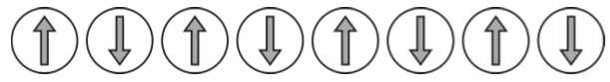

What type of magnetism is shown by this substance?

(b) What type of stoichiometric defect is shown by (i) KC*l* (ii) AgC*l*?

(ii) An element with density 11.2 g cm–3 forms a fcc lattice with edge length of 4 × 10–8 cm. Calculate the atomic mass of the element. (NA = 6.02 × 1023 mol–1)

1. Silver metal crystallizes with a face centered cubic lattice. The length of the unit cell is found to be 3.0 × 10–8 cm. Calculate atomic radius and density of silver. (Molar mass of Ag = 108 g mol–1, NA = 6.02 × 1023 mol–1).
2. (a) What is the radius of sodium atom if it crystallizes in bcc structure with the cell edge of 400 pm?

(b) Examine the given defective crystal:

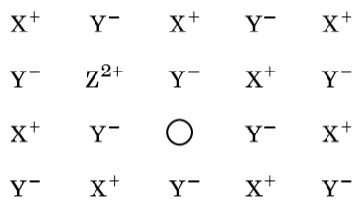

(i) Write the term used for this type of defect.

(ii) What is the result when XY crystal is doped with divalent (Z2+) impurity?

1. What is the formula of a compound in which the element P forms ccp lattice and atoms of Q occupy 2/3rd of tetrahedral voids?
2. (a) An element has atomic mass 93 g mol–1 and density 11.5 g cm–3. If the edge length of its unit cell is 300 pm, identify the type of unit cell.

(b) Write any two differences between amorphous solids and crystalline solids.

1. (a) Calculate the number of unit cells in 8.1 g of aluminium if it crystallizes in an f.c.c. structure. (Atomic mass of A*l* = 27 g mol–1)

(b) Give reasons:

(i) In stoichiometric defects, NaCl exhibits Schottky defect and not Frenkel defect.

(ii) Silicon on doping with Phosphorus forms n-type semiconductor.

(iii)Ferrimagnetic substances show better magnetism than antiferromagnetic substances.

1. An element crystallizes in a f.c.c. lattice with cell edge of 400pm. The density of the element is 7 g cm-3. How many atoms are present in 280 g of the element?
2. What type of magnetism is shown by a substance if its domains are arranged in equal number and in opposite directions?
3. ZnO turns yellow on heating, why?
4. What would be the nature of the solid if there is no energy gap between valence band and conduction band?
5. An element crystallizes in a b.c.c. lattice with cell edge of 400pm. Calculate the density if 250 g of this element contains 2.5 × 1024 atoms.
6. An element crystallizes in a b.c.c. lattice with cell edge of 500pm. The density of the element is 7.5 g cm-3. How many atoms are present in 300g of the element?
7. An element crystallizes in a f.c.c. lattice with cell edge of 250pm. Calculate the density if 300 g of this element contains 2.0 × 1024 atoms.
8. What is the formula of a compound in which the element Y forms ccp lattice and atoms of X occupy 1/3rd of tetrahedral voids?
9. An element with molar mass 27 g mol–1 forms a cubic unit cell with edge length 4.05 ×10–8 cm. If its density is 2.7 g cm–3, what is the nature of the cubic unit cell?
10. How many atoms constitute one unit cell of a face centered cubic crystal?

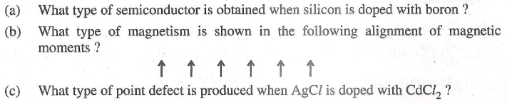

2. Explain how you can· determine the atomic mass of an unknown metal if you know its mass density and the dimensions of unit cell of its crystal.
3. Calculate the packing efficiency of a metal crystal for a simple cubic lattice.
4. Calculate the number of unit cells in 8·1 g of aluminium if it crystallizes in a face-centered cubic (f.c.c.) structure. (Atomic mass of Al = 27 g mol-1)
5. (i) Write the type of magnetism - observed when the magnetic moments are appositively aligned and cancel out each other.

(ii) Which stoichiometric defect does not change the density of-the crystal?

1. An element with density 2·8 g cm-3 forms a f.c.c. unit cell with edge length 4 x10-8 cm. Calculate the molar mass of the element. (Given: NA= 6·022 X 1023 rnol-1).
2. How may the conductivity of an intrinsic semiconductor be increased?

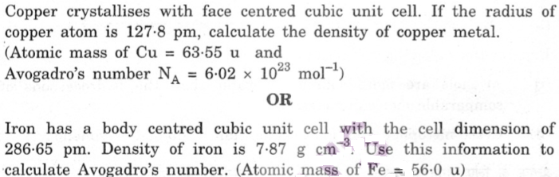



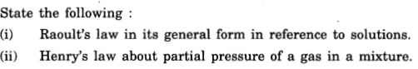

1. Crystalline solids are anisotropic in nature. What does this statement means?
2. 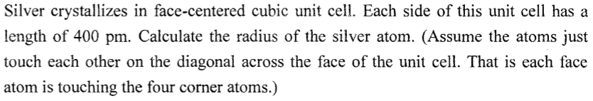
3. What type of interactions holds the molecule together in a polar molecular solid?
4. 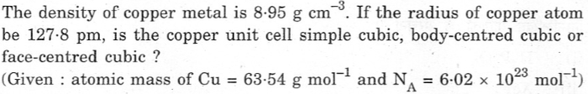
5. What is the coordination number of each type of ions in a rock-salt type crystal structure?
6. What is a semiconductor? Describe the two main types of semiconductors and explain mechanisms for their conduction.
7. What type of substances exhibit antiferromagnetism?
8. Define the ‘forbidden zone’ of an insulator.
9. Niobium (Nb) crystallizes in a body-centered cubic (bcc) structure. If its density is 8.55 g cm-3, calculate the atomic radius of niobium.

(Atomic mass of Nb = 93 u; NA = 6.02×1023 mol -1)

1. Explain with suitable examples the following : (a) n-type and p-type semiconductors (b) F-centers (c) Ferromagnetism
2. Which crystal defect lowers the density of a solid?
3. Name an element with which silicon may be doped to give a p-type semiconductor.
4. Which point defect in crystals does not alter the density of the relevant solid?
5. Iron has a body-centered cubic unit cell with a cell edge of 286.65 pm. The density of iron is 7.87g cm–3. Use this information to calculate Avogadro’s number (At. mass of Fe = 56g mol–1).
6. How do metallic and ionic substances differ in conducting electricity?
7. Silver crystallizes with face-centered cubic unit cells. Each side of the unit cell has a length of 409 pm. What is the radius of an atom of silver? (Assume that each face atom is touching the four corner atoms.)
8. The well known mineral fluorite is chemically calcium fluoride. It is known that in one unit cell of this mineral there are 4 Ca2+ ions and 8 F– ions and that Ca2+ ions are arranged in a fcc lattice. The F– ions fill all the tetrahedral holes in the face centered cubic lattice of Ca2+ ions. The edge of the unit cell is 5.46 × 10–8 cm in length. The density of the solid is 3.18 g cm–3. Use this information to calculate Avogadro's number (Molar mass of CaF2 = 78.08 g mol–1)
9. What type of interactions hold the molecules together in a polar molecular solid?
10. What type of semiconductor is obtained when silicon is doped with arsenic?
11. Silver crystallizes in fcc lattice. If the edge length of the unit cell is 4.07 × 10–8 cm and the density of the crystal is 10.5 g cm–3, calculate the atomic mass of silver.

(NA = 6.02 × 1023 atoms mol–1)

1. The density of lead is 11.35 g cm–3 and the metal crystallizes with FCC unit cell. Estimate the radius of lead atom. (At. mass of lead = 207 g mol–1 and NA = 6.02 × 1023 mol –1).

**……………………..**